Created by: Christine Mauro

Date created: 03/11/2020

Last Update: N/A

How to use iPad and Apple Pencil for lecturing.

Before you get started, you need to go through the following process (Step 1-6) **ONCE**.

1. Download the app GoodReader to your iPad.
2. Select Connect on the bottom panel.
3. Once in the connect tab, select the + button, and choose Dropbox.
4. In Readable TItle, enter a name for your Dropbox (Dropbox works fine!), then Add.
5. Now click on Dropbox icon and enter your email/password connect.
6. GoodReader is now connected to your Dropbox account.

Once you’ve configured GoodReader, here’s what you need to do **before each lecture**:

1. Create lecture content and save as PDF on Dropbox.
   1. If you prefer to do all of your notes live, just create a blank word document with several pages at this point and save that as a PDF.
2. Open GoodReader and select Connect on the bottom panel.
3. Select Dropbox and navigate to your lecture file.
4. Select your lecture file and hit Download.
5. Select where on GoodReader you want the file to download (you can create folders to organize your files on GoodReader) and then select Download Here.

To annotate **during lecture**:

1. Navigate to that folder on GoodReader where you downloaded the file and Select it. It will open the file for you. You can now start annotating!
2. Start annotating using the panel on the right hand side. If the panel disappears, you can tap with two fingers to make it reappear.
   1. When you make your first annotation, GoodReader will ask if you want to save an annotated copy. I always select yes.
3. After you’ve finished annotating, press the X button in the top left corner (again, a two finger tap will make it appear).

To upload your annotated notes **after lecture**:

1. On the home screen, select Manage Files button on bottom left hand side.
2. Select the circle next to the annotated lecture file you wish to upload. It should now be highlighted in green.
3. Select Upload. This should connect you back to Dropbox.
4. Find the location on Dropbox where you’d like to save the annotated file.
5. Select “Upload 1 Preselected item”
6. You are done! The annotated file should now be on Dropbox!

Example of lecture notes prior to annotating:

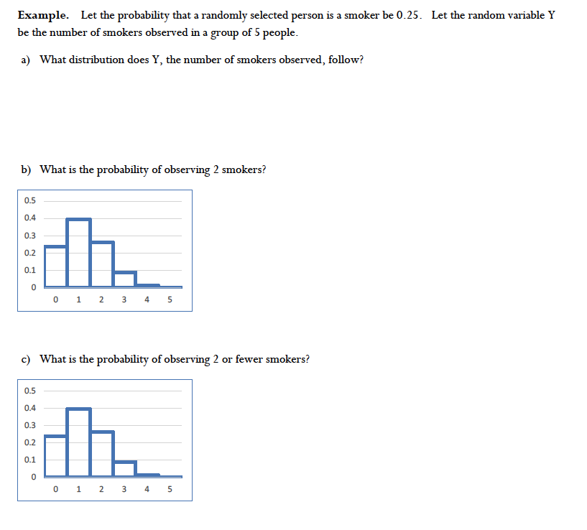

Example of lecture notes after annotating (annotating done live in lecture):

